Sexual Violence in Rural Communities
Introduction
According to a Maryland Rape Prevention and Education Program Needs Assessment Phase 1 Report, prepared for Maryland Rape and Sexual Assault Programs, sexual violence survivors from underserved populations, such as people of color, members of the LGBTQ+ community, and individuals in rural communities, are more likely to experience additional barriers to accessing supportive sexual violence resources and services. This may be because of systems of oppression, like racism, sexism, ableism, ageism, etc., which give some people more power in society while causing others to face additional barriers to accessing the same resources or services.
FACT SHEET
Rural communities are a unique subset of underserved populations because rural communities face additional barriers to accessing services that urban and suburban communities may not. These additional barriers may include access to reliable transportation or specialty healthcare providers; access to reliable internet or broadband;, access to financial, housing, and food security; and more. These barriers may be due to geography, transportation, and internet or broadband infrastructure, and urban jobs paying higher than rural ones which may influence service providers to take jobs outside of rural areas. While rural communities face these additional challenges, there may also be rural survivors of sexual violence who are a part of other underserved populations, too. For example, a rural survivor of color, rural survivor with a disability, or rural survivor from the LGBTQ+ community may experience more barriers to accessing services or support due to their intersecting identities which can influence how society treats them and how they navigate different types of support.
According to the Maryland State Office of Rural Health, 18 of Maryland’s 24 jurisdictions are defined as “rural.” Maryland’s rural counties are Allegany, Calvert, Caroline, Carroll, Cecil, Charles, Dorchester, Frederick, Garrett, Harford, Kent, Queen Anne’s Somerset, St. Mary’s, Talbot, Washington, Wicomico, and Worcester.
Statistics
There is limited available data on the prevalence of sexual assault in rural areas within Maryland and the U.S. because sexual assault is often underreported in rural areas. For more information on why sexual assault often goes underreported, refer to MCASA’s fact sheet on “Why Survivors Don’t Report.”
However, according to the CDC, the following factors could put someone at a higher risk of experiencing sexual violence perpetration: poverty, a lack of employment opportunities, and a general tolerance of sexual violence within the community. Many of these factors are present in rural Maryland.

The U.S. Census Bureau collects statewide data, including data on Maryland’s rural counties and the average commute time to work, percentage of residents without healthcare coverage, employment rates, and poverty rates. This information is shown in the graphs below. ,,,,,,,,,,,,,,,,,,
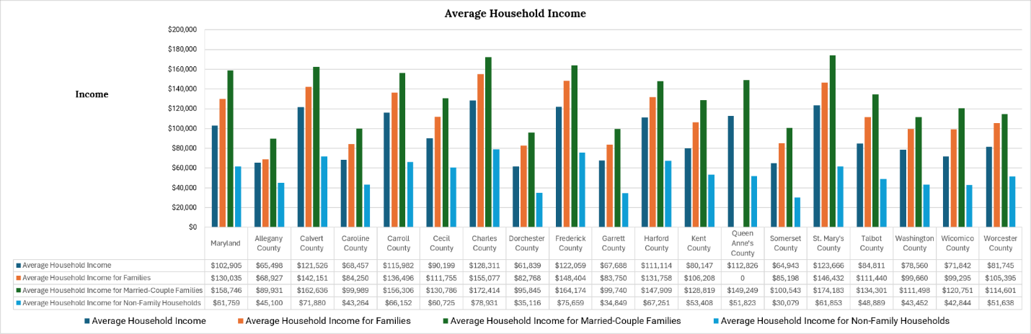
When rural survivors of sexual violence do not have the means to access employment opportunities, reliable transportation, specialty healthcare providers, affordable housing, and survivor-centered support and resources, they are at a greater risk of experiencing sexual violence.
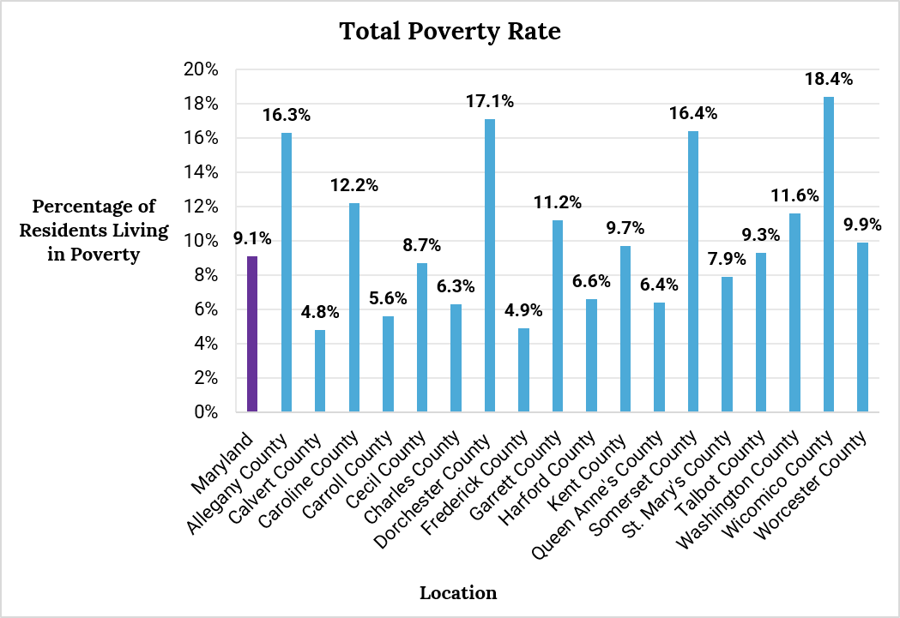

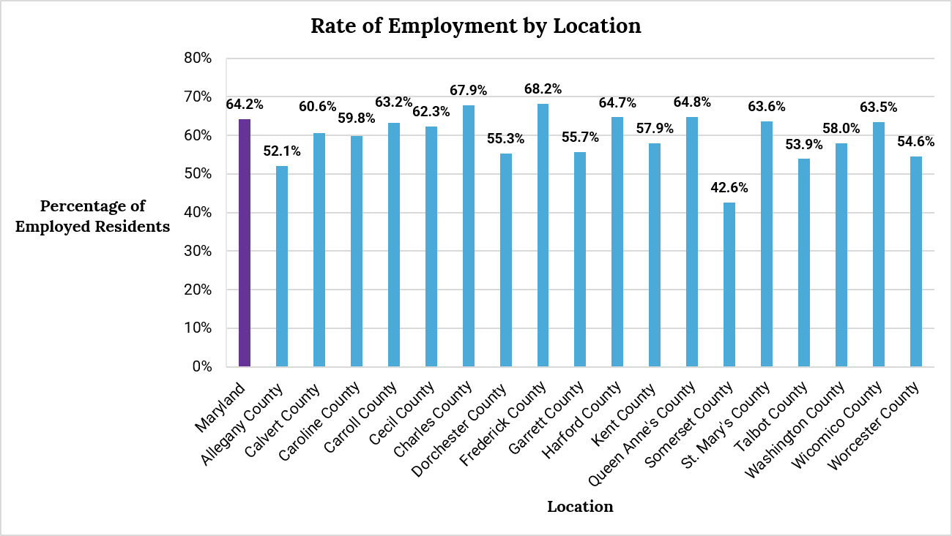

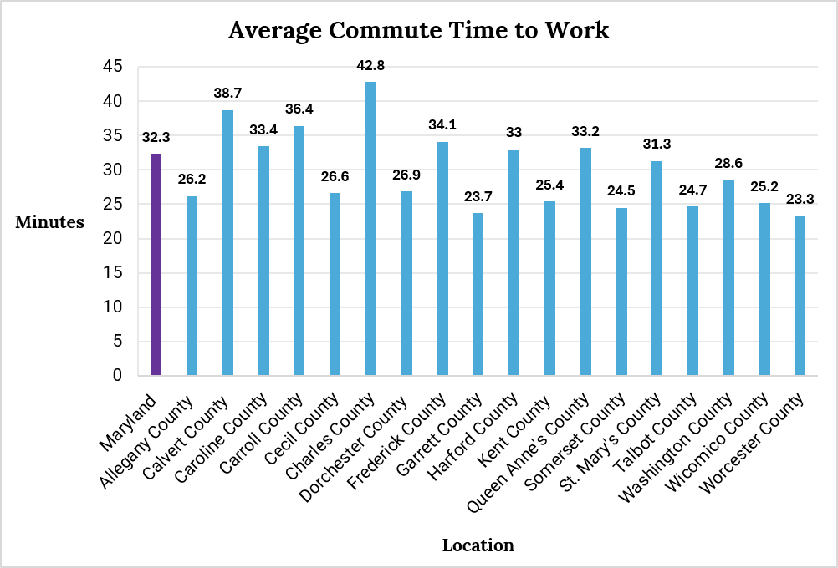

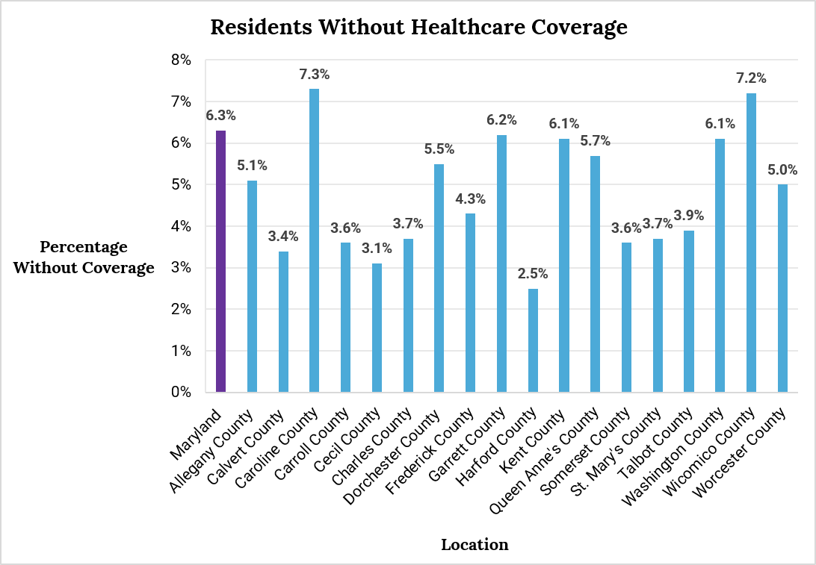

According to 2024 data from Feed America, 14.6% of Marylanders are food insecure.
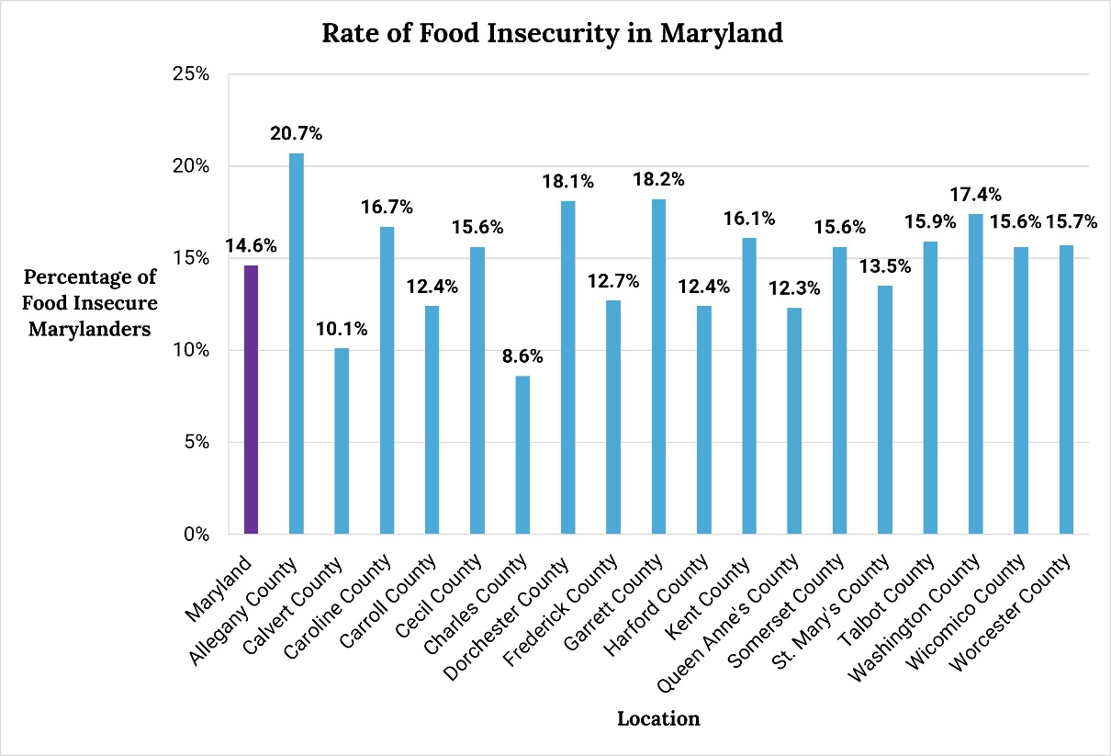

University of Washington, School of Social Work. (2015-2026). “Oppression.” Retrieved August 18, 2026, from https://socialwork.uw.edu/admissions/oppression-definition/
Maryland Rural Health Association. (n.d.). “2018 Maryland Rural Health Plan.” Additional Contributors: Maryland Department of Health: State Office of Rural Health, Rural Maryland Council, & Robert Wood Johnson Foundation. Retrieved August 14, 2026, from https://health.maryland.gov/pophealth/Documents/Rural%20Health/MDRH-Plan-2018.pdf
Curtis, M.. E., Clingan, S,. E., Guo, H., Zhu, Y., Mooney, L. J., & Hser, Y. (2022). “Disparities in Digital Access Among American Rural and Urban Households and Implications for Telemedicine-Based Services.” The Journal of Rural Health. Retrieved August 14, 2026, from https://pmc.ncbi.nlm.nih.gov/articles/PMC9827725/pdf/nihms-1851104.pdf
Graves, J. M., Abshire, D. A., Amiri, S., Mackelprang, J . L. (2021). “Disparities in Technology and Broadband Internet Access Across Rurality: Implications for Health and Education.” Journal of Family and Community Health. Retrieved August 14, 2026, from https://pmc.ncbi.nlm.nih.gov/articles/PMC8373718/pdf/nihms-1709004.pdf
Yates, J., Sillington, K. J., Tryphonopoulos, P., Jackson, K. T., & Mantler, T. (2023). “‘When I Decided to Leave, I had Nothing’: The Resilience of Rural Women Experiencing Economic Abuse in the Context of Gender-Based Violence.” Journal of Rural and Community Development. Retrieved August 14, 2026, from https://journals.brandonu.ca/jrcd/article/view/2225/605
National Resource Center on Domestic Violence. (2025). “Applying an Intersectional Lens.” VAWnet. Retrieved August 18, 2026, from https://vawnet.org/sc/how-faithreligion-can-best-meet-needs-abuse-survivors-those-who-cause-harm/applying
Maryland Department of Health (MDH), State Office of Rural Health (SORH). (2026, July). “SORH Mission.” Retrieved August 14, 2026, from https://health.maryland.gov/pophealth/pages/rural-health.aspx
Maryland Department of Health (MDH), State Office of Rural Health (SORH). (2026, July). “SORH Mission.” Retrieved August 14, 2026, from https://health.maryland.gov/pophealth/pages/rural-health.aspx
Ditter, L. & Qi, Z. (2024). “An Economic Advocacy Approach to Empower Rural Victims of Gender-Based Violence: A Review of the Literature.” Academic Leadership Journal in Student Research. Retrieved August 20, 2026, from https://scholars.fhsu.edu/cgi/viewcontent.cgi?article=1113&context=aljsr as cited in Peek-Asa, C., Wallis, A., Harland, K., Beyer, K., Dickey, P., & Saftlas, A. (2011). “Rural Disparity in Domestic Violence Prevalence and Access to Resources.” Journal of Women’s Health. Retrieved August 20, 2026, from https://journals.sagepub.com/doi/10.1089/jwh.2011.2891
U.S. Centers for Disease Control & Prevention (CDC). (2024, January). “Sexual Violence Prevention: Risk and Protective Factors.” Retrieved August 14, 2026, from https://www.cdc.gov/sexual-violence/risk-factors/index.html
The United States (U.S.) Census Bureau. (n.d.). “Maryland Profile.” Retrieved August 14, 2026, from https://data.census.gov/profile/Maryland?g=040XX00US24
The United States (U.S.) Census Bureau. (n.d.). “Allegany County, Maryland Profile.” Retrieved August 14, 2026, from https://data.census.gov/profile/Allegany_County,_Maryland?g=050XX00US24001
The United States (U.S.) Census Bureau. (n.d.). “Calvert County, Maryland Profile.” Retrieved August 14, 2026, from https://data.census.gov/profile/Calvert_County,_Maryland?g=050XX00US24009#populations-and-people
The United States (U.S.) Census Bureau. (n.d.). “Caroline County, Maryland Profile.” Retrieved August 14, 2026, from https://data.census.gov/profile/Caroline_County,_Maryland?g=050XX00US24011
The United States (U.S.) Census Bureau. (n.d.). “Carroll County, Maryland Profile.” Retrieved August 14, 2026, from https://data.census.gov/profile/Carroll_County,_Maryland?g=050XX00US24013
The United States (U.S.) Census Bureau. (n.d.). “Cecil County, Maryland Profile.” Retrieved August 14, 2026, from https://data.census.gov/profile/Cecil_County,_Maryland?g=050XX00US24015
The United States (U.S.) Census Bureau. (n.d.). “Charles County, Maryland Profile.” Retrieved August 14, 2026, from https://data.census.gov/profile/Charles_County,_Maryland?g=050XX00US24017
The United States (U.S.) Census Bureau. (n.d.). “Dorchester County, Maryland Profile.” Retrieved August 14, 2026, from https://data.census.gov/profile/Dorchester_County,_Maryland?g=050XX00US24019
The United States (U.S.) Census Bureau. (n.d.). “Frederick County, Maryland Profile.” Retrieved August 14, 2026, from https://data.census.gov/profile/Frederick_County,_Maryland?g=050XX00US24021
The United States (U.S.) Census Bureau. (n.d.). “Garrett County, Maryland Profile.” Retrieved August 14, 2026, from https://data.census.gov/profile/Garrett_County,_Maryland?g=050XX00US24023
The United States (U.S.) Census Bureau. (n.d.). “Harford County, Maryland Profile.” Retrieved August 14, 2026, from https://data.census.gov/profile/Harford_County,_Maryland?g=050XX00US24025
The United States (U.S.) Census Bureau. (n.d.). “Kent County, Maryland Profile.” Retrieved August 14, 2026, from https://data.census.gov/profile/Kent_County,_Maryland?g=050XX00US24029
The United States (U.S.) Census Bureau. (n.d.). “Queen Anne’s County, Maryland Profile.” Retrieved August 14, 2026, from https://data.census.gov/profile/Queen_Anne%27s_County,_Maryland?g=050XX00US24035
The United States (U.S.) Census Bureau. (n.d.). “Somerset County, Maryland Profile.” Retrieved August 14, 2026, from https://data.census.gov/profile/Somerset_County,_Maryland?g=050XX00US24039
The United States (U.S.) Census Bureau. (n.d.). “St. Mary’s County, Maryland Profile.” Retrieved August 14, 2026, from https://data.census.gov/profile/St._Mary%27s_County,_Maryland?g=050XX00US24037
The United States (U.S.) Census Bureau. (n.d.). “Talbot County, Maryland Profile.” Retrieved August 14, 2026, from https://data.census.gov/profile/Talbot_County,_Maryland?g=050XX00US24041
The United States (U.S.) Census Bureau. (n.d.). “Washington County, Maryland Profile.” Retrieved August 14, 2026, from https://data.census.gov/profile/Washington_County,_Maryland?g=050XX00US24043
The United States (U.S.) Census Bureau. (n.d.). “Wicomico County, Maryland Profile.” Retrieved August 14, 2026, from https://data.census.gov/profile/Wicomico_County,_Maryland?g=050XX00US24045
The United States (U.S.) Census Bureau. (n.d.). “Worcester County, Maryland Profile.” Retrieved August 14, 2026, from https://data.census.gov/profile/Worcester_County,_Maryland?g=050XX00US24047
Feeding America. (2026). “Food Security Among the Overall Population in Maryland.” Retrieved August 20, 2026, from https://map.feedingamerica.org/county/2024/overall/maryland

